Student's name: _________________________________________ Date: October 7, 2019

Put a tick under the smiley that shows to what extent the statement is true for the presenting student.  Stavi kvačicu pod smjeka koji pokazuje u kolikoj je mjeri navedena tvrdnja točna za učenika-prezentera. | 2 points  2 boda | 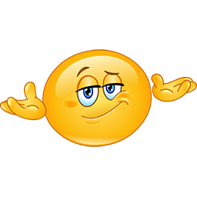  1 point  1 bod | 0 points  0 bodova
The student followed the teacher's instructions.
Učenik/ca je ispoštovao/la učiteljičine upute.
The student named the computer game.
Učenik/ca je osmislio/la naziv svoje igrice.
The student created the logo of the game.
Učenik/ca je osmislio/la logo svoje igrice.
The student named/listed the characters in the game.
Učenik/ca je naveo/la likove u svojoj igrici.
The student described the game.
Učenik/ca je opisao/la svoju igricu.
The student named the target group.
Učenik/ca je naveo/la kome je igrica namjenjena.
The student was loud and clear when presenting.
Učenik/ca je bio/la dovoljno glasna i razgovjetna prilikom prezentiranja.
The student was creative in the project of designing a new computer game.
Učenik/ca je bio/la kreativna u projektu osmišljavanja nove računalne igrice.

Total possible points: 16  Total earned points: _____ | Comments:

